Code document:
Camera system:
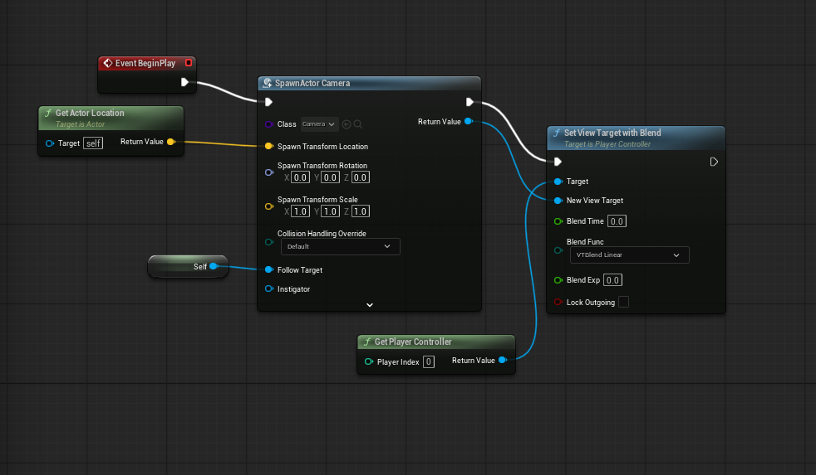
(bp_thirdpersoncharacter)
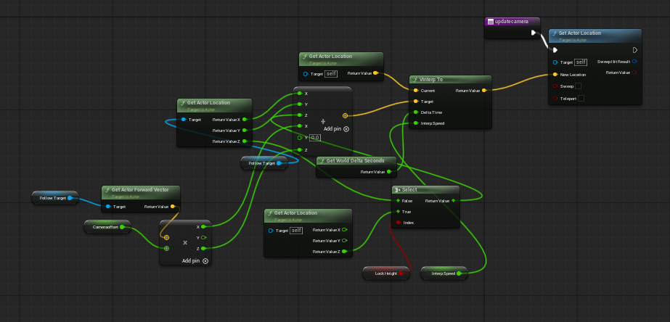
(bp_camera)
The 2.5d camera system work through an actor blueprint that use a camera and spring arm with some base setting changed. Blueprint wise we must cover the variable follow target which within the character blueprint is set to the third person base character, this allows me get 2 different sets of locations which then can be added to create different effects.
To more fully customise the camera, I used a split struct on the addition, so it’d work on floats rather than vectors, on the first part of the add the characters xy base values are added to the camera, this added along with the character forward vector times by the camera offset a custom variable. Which then adds it x and z values to the xy values of the character to make the camera be further away from the base character giving more focus to the scene and more dynamic movement. Finally, the characters base z value runs off a variable which allows 2 options for the camera, either follow the characters jump or to lock the z value and not allow the camera to follow, this work by using either the camera or the character base z value then running a select node to decide what to use based on the Boolean. Before connecting this up to the cameras location I had to implement a v interp to create a smoother feeling, with the base “current” location being the cameras location then the target being the result of the addition, this is then run on the delta seconds and interp speed another variable to decide how fast it moves to the desired location, finally this connect to set the cameras location.
This only the function of the code though as if it was just in the event graph this would only happen once so within the event graph a simple event tick and call of the function, so it’d run every second and continually move the camera.
This would work fine but the camera wasn’t present in the scene due to not being placed in scene but that would cause problems with it always starting out in a static position no matter the levels starting position, so within the character blueprint I run a event begin play that then spawn the camera, then uses the character location to give its base position, and to finally give actual definition to ue5 of what the follow target is through a reference to self. this then go into a blend that use the character as the starting target and the new view target being the cameras new position that it found through the previous code.
Move set:
Big jump:
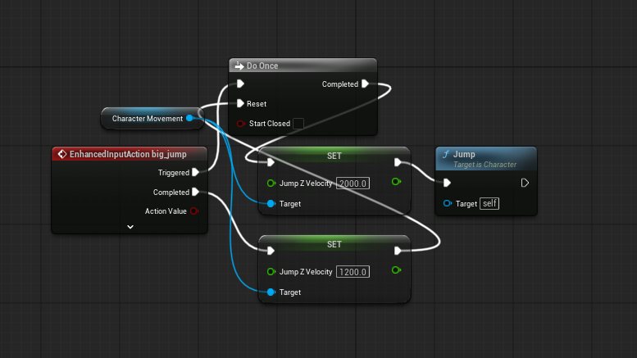
(bp third person character)
Big jump refers to the variable jump with the base option still being present but also recognising a hold as a big jump, this work by when the ue5 receives the input it run through a do once to stop the jump from spamming every frame the key is down, then setting the jump z velocity higher and running the jump event.
Once the input is completed it reset the jump height and the do once.
Dive:
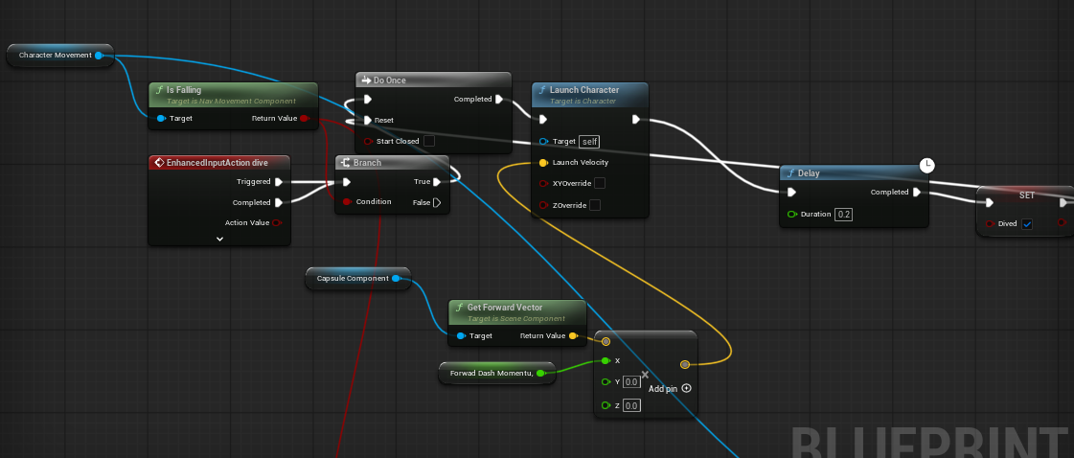
(bp third person character)
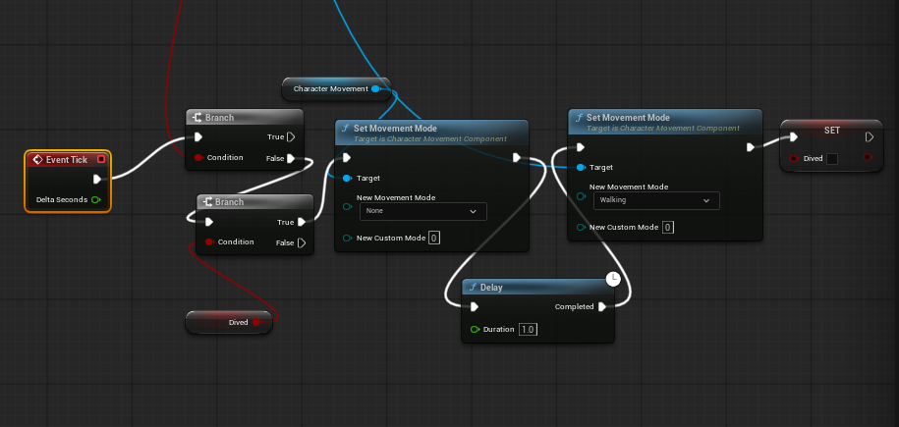
(bp third person character)
The dive system has 2 different aspects to it the initial jump itself then the stun afterwards.
The dive itself work through getting the character movement component then get is falling? so I can run it through a branch, if true it go throughs a do once which then launch the character based on it forward vector times by the custom variable forward dash momentum but only its x value this then is plugged in to the launch node which then runs a delay and make the bool dived true, once this is complete the do once resets.
The stun mechanic runs on an event tick (I need find a better option here for optimising, too many event ticks= bad) which goes through 2 branches checking if the player is on the ground and if so, is dived true, if all true set the character movement mode to none, run a delay then set it back to walking after this the dived variable goes to false.

Lock & Key Mechanism
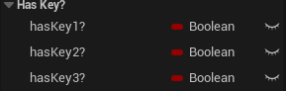
These Boolean values were created on BP_ThirdPersonCharacter and categorised to avoid cluttering.

To make it so one object works for the different key types I anticipate us adding, an enumeration named “Keys” was created and currently has the 3 temporary values ‘key1’ ‘key2’ and ‘key3’
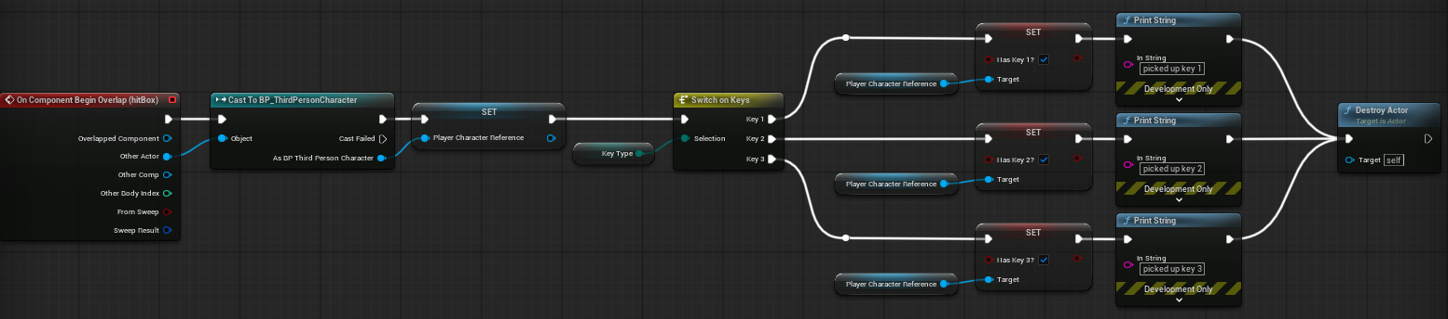
The ‘BP_keyPickup’ object is currently a sphere with a hitbox, when the player overlaps this hitbox, it casts to the player and changes the boolean of the key assigned to the pickup to true, and then destroys itself.

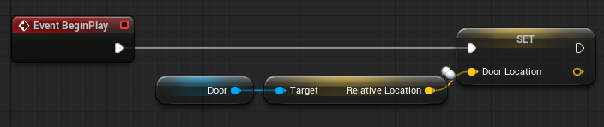
When the game starts, the door checks it’s current position in the world and saves it as ‘doorLocation’

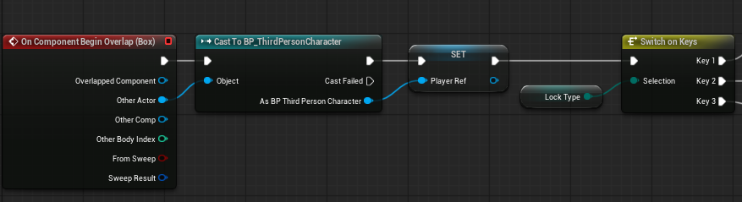
The door then uses the same on begin overlap logic as the key pickup

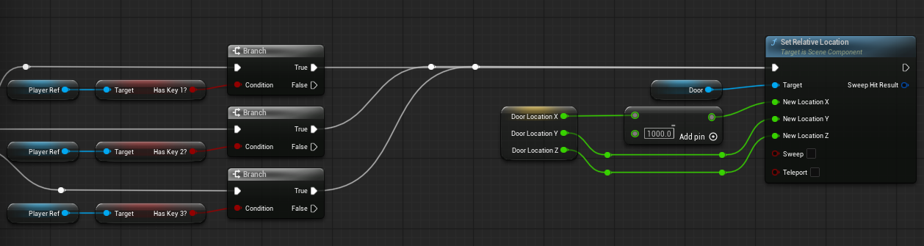
The door then checks the player to see if they have the relevant key, and if they do it moves out of the way.

